Building a Motor
In this lesson's investigation, you'll explore the relationship between electricity and magnetism by seeing how an electromagnet can be used to build a small electric motor.

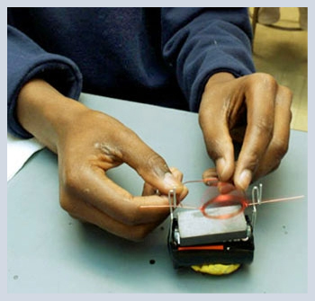

The Electromagnet
To build an electromagnet, you wrap a coiled wire around a nail or a screw, to provide a metallic core.
What was the role of the metallic core? The metallic core has magnetic domains that line up in response to the magnetic field created by the coiled wire. Once the domains are aligned in the metallic core, it becomes a magnet itself.

Is the metallic core necessary to make a magnetic field? The magnetic field is produced by the wire carrying current whether or not there is a metallic core. The metallic core makes the electromagnet much stronger, but a lone coil of wire with current running through it will still act as a magnet.

To build a motor, a coil of wire is used to run current through it. This produces a magnetic field that can be seen using a compass.
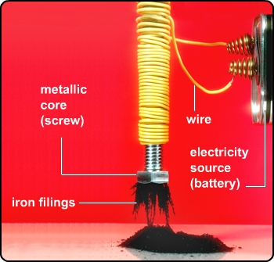

Electromagnet and Compass
How does an electromagnet affect a compass? Dakota followed the first part of the electromagnet and motor procedure. This is what she observed.

Accordion: Electromagnet and Compass

Directions: Select a header to expand or collapse content in each section.


MS Science 8 M10L13 CBV Accordion Image 1.

Section 1: Power Added

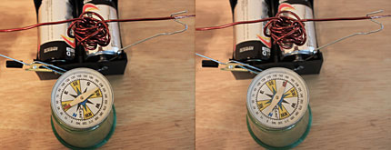
MS Science 8 M10L13 CBV Accordion Image 2.

Section 2: Opposite Side of Coil

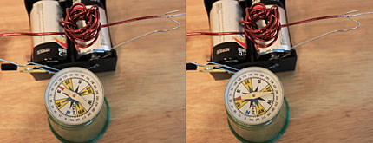
MS Science 8 M10L13 CBV Accordion Image 3.

Section 3: Coil Flipped End to End

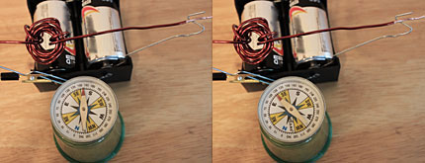

MS Science 8 M10L13 CBV Accordion Image 4.
Study Club: Build an Electric Motor

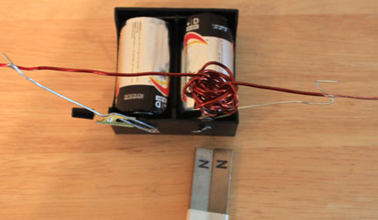
Screen 1

Build an Electric Motor

Image shows two batteries in a battery cradle, as well as a piece of coiled wire connected to two outstretched paper clips. One of the ends of the coiled wire is connected to an outstretched paper clip that is also connected to a terminal of the cradle. The other end of the coiled wire is connected to yet another outstretched paper clip that is connected to another terminal of the battery cradle. Two bar magnets, showing N for north pole of the magnets, is shown lying on the table.

Dakota: This is the motor assembly I made that includes the coil, the cradle and contact system, and the two magnets taped together with matching poles side by side. Notice that the right side of the wire is painted with the nail polish on the top side.

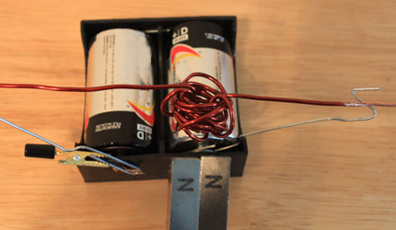
Screen 2

The Motor Spins

Image shows two batteries in a battery cradle, as well as a piece of coiled wire connected to two outstretched paper clips. One of the ends of the coiled wire is connected to an outstretched paper clip that is also connected to a terminal of the cradle. The other end of the coiled wire is connected to yet another outstretched paper clip that is connected to another terminal of the battery cradle. Two bar magnets, showing N for north pole of the magnets, is shown placed close to the coil of the wire,

Dakota: As I held the two magnets near the coil, the coil began to spin quickly.

Assignment: Build an Electromagnet and a Motor Investigation
Complete and answer the questions about the motor.

